Impacts of Covid-19 in the hospitality sector in Denmark
Bettina Lyngsdal Baumgarten, Dania Academy
beba@eadania.dk

Abstract:
Through 2021 and 2022 I have been part of a research group under the research programme, Nordplus. Our aim has been to investigate how the pandemic has impacted the hospitality industry in selected northern countries, Denmark, Iceland, and Latvia. We have been using mixed methods, desk, and field research to have as much data to conclude the impacts of the pandemic. In the following article I will introduce my main findings from the hospitality sector in Denmark to see how the pandemic has affected the hotel industry in particular.
In the case of Aarhus, the focus will be on the findings from the conducted qualitative interviews. I will go through the findings from the six qualitative interviews conducted by myself.
In the case of Copenhagen, I have used desk research for my findings.
Hotel industry of Aarhus
In the case of Denmark, I will start with my findings from 6 in depth qualitative interviews that I have conducted with senior managers from MICE hotels in the city of Aarhus, Denmark (May 2022). All interviews were conducted online and subsequently recorded and analyzed by the research group at Dania Academy. The following analysis will be divided into themes according to the question frame used in the interviews.

Economic considerations
Several of the respondent mentioned, that their survival depended on the “financial strength” of the mother company behind, from which they were directly supported by or by the investors behind the company to survive. Therefore, they refused to receive the financial aid packages from the Danish government so not to incur debts in the wake of the pandemic, still with the purpose for all the respondents to “survive” the pandemic and ultimately “get back on their feet”. The pandemic has been a period of strategic still stand – survival was the name of the game! Focus on the daily operations rather than on what happens afterwards and future trends. As the interviews were conducted in May 2022, more of the respondents mentioned several times the war in Ukraine as the next crisis that might be more devastating than Covid-19 due to increase in prices for i.e., heating, energy, and foods.
None of the respondents mentioned a changed pricing strategy during (and after) the pandemic, meaning that none of the hotels lowered their prices or on the opposite, increased them. Yet, a small increase in prices for MICE tourism taking place in the hotels from 2023, were already considered in the spring of 2022, due to the impact of the war in Ukraine, leading to higher inflation. However, most of the respondents asses that they are back to normal (2019) already now (May 2022) and expect a summer period with growth.

Employees
First of all, safety was throughout the pandemic seen as a key issue, both for the employees but also for the guests. All the respondent mentioned that the agility and readiness to change among their employees was a key factor in their ability to weather the crisis. This led to, that the employees, and their leaders, were having a more holistic view of the hotel, as both managers and employees had to learn to work in other departments than their usual ones, due to staff shortage. This meant, that several of the managers had to work both as dishwashers and cleaning staff, and on the other hand, the receptionist had to learn how to prepare i.e., breakfast and dinner for the guests. Consequently, this led to more “bottom-up” leadership as the employees, to a wider degree, were involved in making the decisions during the pandemic, which also has influenced a positive culture change in all the hotels. Furthermore, all the respondents has had a strong focus on reboarding staff to be ready for restrictions to be removed and consequently rising demand.

Sustainability
All of the respondents already worked with SDG 17 as part of their business model, more of them had several times received sustainability awards. The period of the pandemic was seen as a way of either increasing this commitment or trying out new and more sustainable business models. The focus here were the Important learnings following the pandemic pertaining to the 17 (SDG’s): 1) Reduction of food waste because of serving “portion sizes” in the restaurant (Goal 12), 2) Valuing and caring more for their employees (Goal 8).

Other changes as consequence of the pandemic
- Lead time has been shortened substantially as a change in customer behaviour
- More flexible cancellation policies have been introduced
- The digital guest meeting will not replace the physical one. The “moment of truth” in the offline world will still be the most important. A tendency (trend) for other activities to take place when companies are having conferences, than “just” the business meeting is requested much more than before the pandemic
- A much stronger bond has occurred with the guest because of pandemic

Hotel industry of Copenhagen
All the respondents in Aarhus mentioned that while other parts of the hotel sector in Denmark had recovered, this was not the case in Copenhagen. To investigate this further, I have for this case made some desk research (October 2022). I have to mention that more post-pandemic data has been available in this particular case compared to all the other paragraphs in this article.
In the period before the pandemic (2019), the Copenhagen hotels experienced a large increase in the number of overnight guests (16% more compared to 2017), and especially foreign tourists contributed to rising prices and occupancy levels. Historically, foreign tourists have made up over 60% of the total overnight stayers, where tourists from Sweden, Norway, Germany, and the USA made up approx. half of the foreign tourists. From the beginning of the outbreak of Covid-19 the hotel industry in Copenhagen experienced a decrease in occupancy of almost 70% compared to the previous year. Occupancy was at its lowest level in April 2020 (PWC 2022).
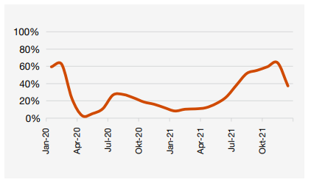
Source: PWC 2022
The low occupancy level was, among other things, due to the controversial six-day rule, which was introduced in June 2020 in connection with Denmark opening its borders. The Danish government made a requirement that foreign tourists needed to have a pre-booking of at least six nights to be allowed to enter Denmark, which had enormous negative effect in the Copenhagen hotel industry. Foreign hotel guests in Denmark are used to come to Copenhagen on short trips and spend an average of 2.2 nights, which during the period this restriction was applicable, increased even lower occupancy levels in the hotels of Copenhagen. The longer-term restrictions with varying closing times and distance requirements as well as pre-order requirements, masks and corona passports have also been part of the challenges. Added to this are the global travel restrictions which have led to uncertain travel patterns.
Another issue that has affected the hotel industry in Copenhagen is that over 5,000 hotel rooms have been opened in Copenhagen alone up to and during the pandemic, and therefore occupancy levels in the hotel industry is still below what the hotels experienced in 2019. According to HORESTA (a Danish industry organization for the hotel, restaurant, and tourism industry) the number of hotel rooms in Copenhagen has increased to 26,000 rooms in 2022.
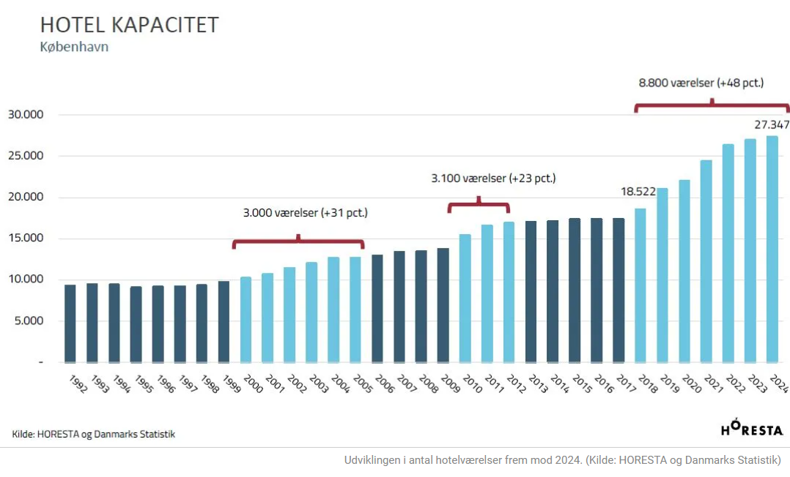
Source: (turisme.nu (3))
Vaerelser is the Danish definition of Rooms
After the pandemic, when the restrictions were removed, foreign guests are visiting Copenhagen again staying overnight in the hotels. This is reflected in the increasing average prices and occupancy levels at the hotels, as in October 2021 was (only) approx. 30% below the level before the pandemic. Large international brands have also moved in to build and operate hotels in the Danish capital, and this fact has seriously forced the hotels to a significant boost in terms of standard and quality. Furthermore, the international brands bring more tourists with them, who would otherwise not have come to Copenhagen, and provides a greater variety in the offer for all segments, this be high-end hotels, unmanned hotels, and others provide large conference facilities which lead to a higher degree of variety of supply (turisme.nu (1)). Danish guests staying in hotels in Copenhagen have had positive effects on the occupancy levels, as danish guest occupancy levels has been going from 40% before the pandemic to 80% in high seasons during and after the pandemic (Standby 2021 (1)).
After perhaps the most unstable period in recent times for the hotel industry, there are positive indications that the demand is returning. Although occupancy levels are not expected to reverse return to pre-pandemic levels yet, or even higher due to more hotel capacity, there are encouraging signs for the hotel industry in Copenhagen. The speed of the recovery is driven by factors beyond the hotel industry's control. The pace depends on the size of especially tourism return as well as international and domestic business trips and events in the capital. To obtain this, safety and security are extremely important factors that must be properly communicated to the guests (turisme.nu (3))
During the high season 2022 the room occupancy in hotels in Copenhagen have fortunately returned to near pre-pandemic numbers:
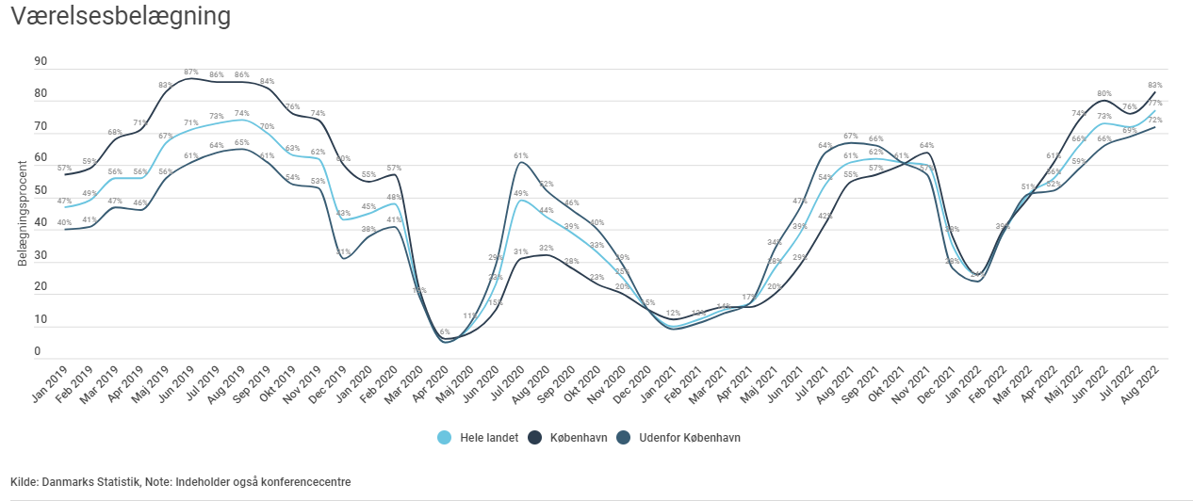
Lack of employees
Many hotels in Copenhagen have been forced to say no to new guests because of lack of employees, specially to clean the rooms and chefs to prepare food. Many foreign maids have returned to their home countries during the lockdown and have not returned. In addition, the Danish government has drastically cut back on international education in Copenhagen, so that the students who used to work as part-time maids no longer come to the capital. To recruit employees it is a fact, that further being expensive, it requires a lot of time putting an even bigger pressure on the employees and managers working in the hotels as there are less people to perform (turisme.nu (2)). It is still a major problem to the hotels in Copenhagen to recruit employees (October 2022). To compare this to the hotels availability to hire staff in i.e., Aarhus, the respondents from the above qualitative interviews mentioned, that they long before the pandemic came to an end, already had hired staff.

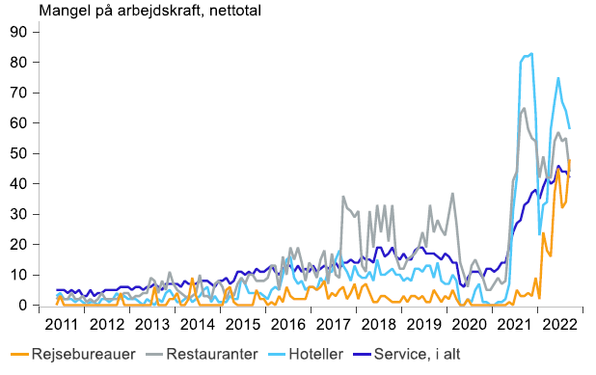
Lack of employees. Dansk Erhverv og Deloitte 2022

War in Ukraine and inflation
As if the corona crisis hasn’t been bad enough, it has now been taken over by the next crisis; the war in Ukraine that has led to high inflation level. The war in Ukraine has a huge negative influence on the desire of oversea tourists to travel to Europe and they are extremely attractive to the hotels in Copenhagen as their daily consumption is significantly higher than other international tourists e.g., within Europe.
The crisis with the high inflation has already shown several new challenges that cause concern and will certainly affect the hotel industry and the key figures for the whole of 2022- and probably for the years to come. The continued lack of labour in the hotels and sharply rising inflation are affecting the expenses in the hotels for electricity, heating, and commodities. The average price of food was 15.9 percent higher in September 2022 compared to the same time last year. The prices of electricity and natural gas rose sharply in 2021, and in 2022 the increases have continued at a rapid pace, in September 2022 alone, the gas price rose 189.2 percent and the electricity price 95 percent compared to the same month last year.
The hotel industry is among the industries where most companies are highly affected by the rising prices. Because the financial losses have been very high in the hotel industry during corona, the new inflation crisis hits an industry already extremely challenged economically. Light, heat and food are the core of what guests staying in a hotel wants, and therefore, it is fundamentally very difficult to reduce the costs without it affecting the guest experience. With the uncertainty of the development of prices, it is difficult for the hotels to price conferences, meetings and stays. A long planning horizon for larger meetings also means that the hotels are extra vulnerable in their business (Standby 2022 (2)).
Research questions for students:
- Which take-aways do you find interesting in the article? Discuss this with the person next to you (take notes for further discussion with the class).
- How has the pandemic influenced the hospitality industry in:
Aarhus
Copenhagen
- Which impacts have been the same and/or different in the two cities – class discussion

Literature
Industry analysis:
Indsigt i hotelbranchen – under en global pandemi (PWC 2022)
https://www.pwc.dk/da/publikationer/2022/brancheanalyse-hotel.pdf
Kæmpe tab ryster hotellerne (Deloitte 2021)
https://www2.deloitte.com/dk/da/pages/brancheanalyser/hotel-og-restaurationsanalysen/hoteller.html
Analyse: Hotelbranchen nærmer sig normalen (Danske Bank 2022)
https://danskebank.com/da/news-og-insights/nyhedsarkiv/insights/2022/26042022
Værelsesbelægning (Horesta 2022)
https://www.horesta.dk/vores-branche/hoteller-i-tal/
Hotel- og Restaurationsanalysen 2022 (Dansk Erhverv og Deloitte 2022)
National strategi for bæredygtig vækst i dansk turisme (juni 2022)
Ferðamálastofa 2021: Ferðaþjónusta á Íslandi – Staða og greining fyrirliggjandi gagna., Ed. Íris Hrund Halldórsdóttir, Akureyri.
Nordplus Project (internal): Björn M. Sigurjónsson, June 2022
Jumpstarting tourism post Covid 19, Milestone 2, The case of Iceland during the covid pandemic, Preliminary analysis of five cases with a review of tourism statistics and literature on business models
Nordplus Project (Internal): Olga Zvereva, April 2022, Hotel School, Hotel Management College, Latvia
Hospitality and MICE, Interviews with the managers and interview analysis, before and during the pandemic 2019 - 2022
Articles:
Københavns hotelscene: Fra støvet og tilbagelænet til internationalt format (turisme.nu (1))
https://turisme.nu/koebenhavns-hotelscene-fra-stoevet-og-tilbagelaenet-til-internationalt-format/
Scandic skriger på arbejdskraft: Fortrøstningsfuld, men frustreret (turisme.nu (2))
https://turisme.nu/scandic-skriger-paa-arbejdskraft-fortroestningsfuld-men-frustreret/
Hotelbranchen i København står overfor mindst 5 enorme udfordringer (turisme.nu (3))
https://turisme.nu/hotelbranchen-i-koebenhavn-staar-over-for-mindst-5-enorme-udfordringer/
Erhvervsturisme post corona: Københavns konferencemarked ramt af ”ketchupeffekt” (turisme.nu (4))
https://turisme.nu/erhvervsturisme-post-corona-slipper-ketchupeffekten-op-i-koebenhavn/
Danskerne gav hotellerne sommerrekord – men stadig sorte skyer (turisme.nu (5))
https://turisme.nu/danskerne-gav-hotellerne-sommerrekord-men-stadig-sorte-skyer/
Genopretning af hovedstadens turisme ”Det bliver et ’tough game*…” (turisme.nu (6))
https://turisme.nu/genopretning-af-hovedstadens-turisme-det-bliver-et-tough-game/
Københavnske hoteller har mange danskere på ferie (Standby 2021 (1))
https://standby.dk/koebenhavnske-hoteller-har-mange-danskere-paa-ferie/
Stigende priser udfordrer hotellers prisstruktur (Standby 2022 (2))
https://standby.dk/stigende-priser-udfordrer-hotellers-prisstruktur/

